Data Visualizations & Queries

Example #1 - Visualization
Flikshop Revenue by Order Type
Section
Orders
Image
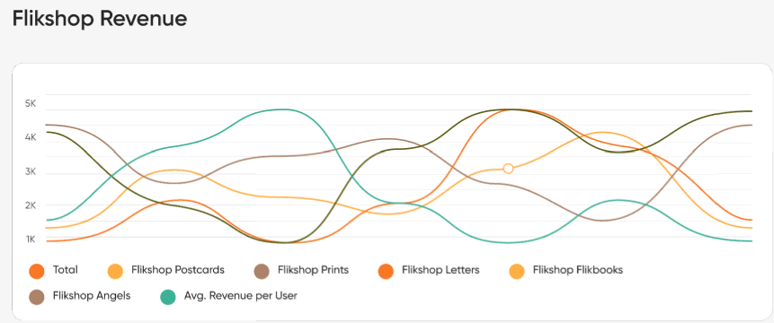
How to approach it:
- Orders table has order_date for time series and order_amount for revenue
- Orders table links to Order_Type via order_type_id (use a join)
- Order_Type table contains order type names for filtering specific products
- User table linked via user_id to calculate average revenue per user
- Extract MONTH and YEAR from order_date using DATE functions
- Calculate multiple metrics per month:
  - Total revenue: SUM(order_amount) for all orders
  - Revenue per order type: SUM(order_amount) filtered by type
  - Avg Revenue per User: Total revenue / COUNT(DISTINCT user_id)
- Group by month to aggregate all metrics
- Filter by date range (appears to show full year)
- Sort chronologically by order_date ASC
- Create separate series for each metric to plot as different lines

Example #2 - Visualization
Sales (by day per month)
Section
Orders
Image
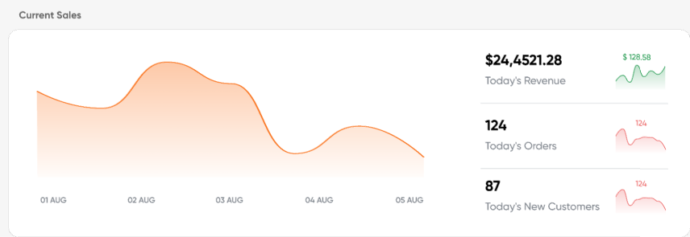
How to approach it:
- Orders table has order_date for daily tracking and order_amount for revenue
- Orders table has user_id to identify customers
- User table tracks when users were created to identify new customers
- Calculate three key metrics for TODAY:
  - Today's Revenue: SUM(order_amount) WHERE order_date = TODAY
  - Today's Orders: COUNT(order_id) WHERE order_date = TODAY
  - Today's New Customers: COUNT(DISTINCT user_id) WHERE user first order = TODAY
- Calculate historical data for the sparkline charts (past 5-7 days)
- Calculate comparison metrics (green/red indicators showing % change vs yesterday)
- Format revenue with currency symbol and proper decimals

Example #3 - Visualization
Devices Accessing the App
Section
Customers
Image
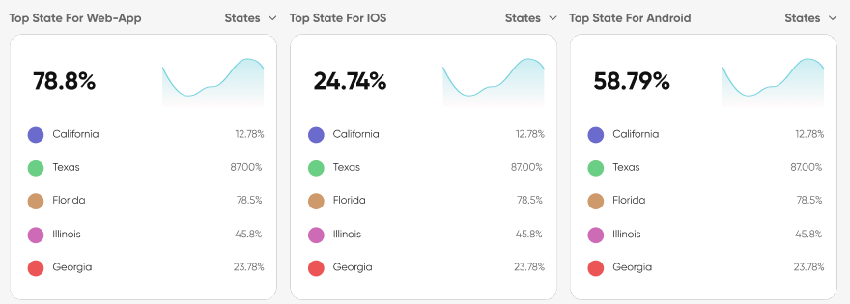
How to approach it:
- User table has device_operating_system field to identify device type
- User table links to Address via address_id (use a join)
- Address table links to State via state_id (use a join)
- Filter users by device type in WHERE clause:
  - Web-App: WHERE device_operating_system = 'Laptop' OR 'Web'
  - iOS: WHERE device_operating_system = 'iOS'
  - Android: WHERE device_operating_system = 'Android'
- Group by state to count users per state per device type
- Calculate total users for that device type
- Calculate percentage: (users in this state / total users for device type) * 100
- Sort by user count DESC to get top states
- LIMIT 5 to show top 5 states only

Example #4 - Query
Number of Postcards Sent to Each Facility
Section
Institutions
Image
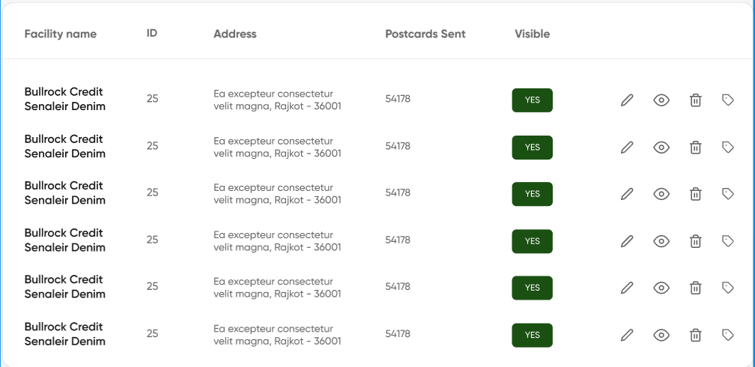
How to approach it:
- Facility table links to Address via address_id (not directly to State)
- Address table links to State via state_id (use a join)
- Address table also links to Country via country_id (use a join)
- Facility table links to Recipient via facility_id (one-to-many)
- Recipient table links to Orders via recipient_id (one-to-many)
- Join Facility → Address → State → Country to build a complete address string
- Join Facility → Recipient → Orders to count postcards sent to each facility
- Use CONCAT() to format address as: "address_line_1, city - zipcode"
- Group by facility_id to aggregate order counts per facility
- Use COUNT(order_id) to get total postcards sent
- Sort by facility_name (optional)

Example #5 - Visualization
Revenue by Month From Each Order Type
Section
Dashboard
Image
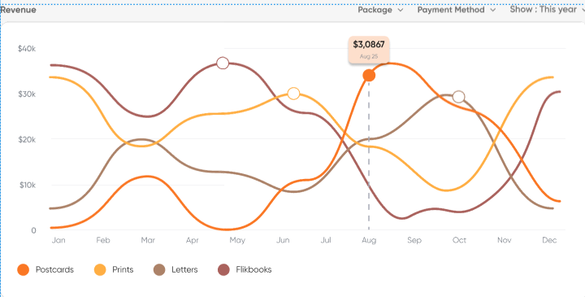
How to approach it:
- Orders table has order_date field to extract month/year
- Orders table has order_amount field containing revenue per order
- Orders table links to Order_Type via order_type_id (use a join)
- Order_Type table contains order type names: 'postcard', 'print', 'flikbook'
- Extract month and year from order_date using DATE functions
- Group by month and order_type to get revenue per type per month
- SUM(order_amount) to calculate total revenue for each group
- Filter by date range using WHERE (ex: WHERE YEAR(order_date) = 2024)
- Sort by date chronologically (ORDER BY order_date ASC)
- Format results so each order type becomes a separate line in the chart

Example #6 - Visualization
Breakdown of Order Types by Facilities in Each State
Section
Dashboard
Image
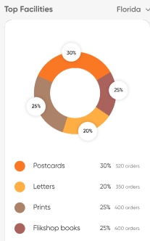
How to approach it:
- Orders table links to Recipient via recipient_id (use a join)
- Recipient table links to Facility via facility_id (use a join)
- Facility table links to Address via address_id (use a join)
- Address table links to State via state_id (use a join)
- Orders table links to Order_Type via order_type_id (use a join)
- Filter by state using WHERE clause (e.g., WHERE state_name = 'Florida')
- Group by facility_id AND order_type to count orders per type per facility
- Count total orders across ALL facilities for percentage calculation
- Calculate percentage: (orders for this type at this facility / total orders) * 100
- Order by order count DESC to get "top" facilities
- LIMIT results to show top facilities only

Example #7 - Visualization
Number of Orders by Repeat Customers
Section
Dashboard
Image
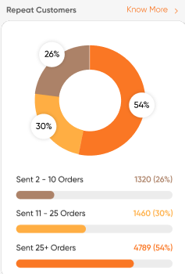
How to approach it:
- Orders table has user_id field linking to User table
- Count how many orders each user has placed using COUNT() with GROUP BY user_id
- Categorize users into buckets based on order count:
  - 2-10 Orders: COUNT(order_id) BETWEEN 2 AND 10
  - 11-25 Orders: COUNT(order_id) BETWEEN 11 AND 25
  - 25+ Orders: COUNT(order_id) > 25
- Use CASE statement to assign each user to a category bucket
- Count how many users fall into each bucket
- Calculate percentage of total users for each bucket
- Exclude users with only 1 order (they're not "repeat" customers)

Example #8 - Visualization
User Geographic Location
Section
Dashboard
Image
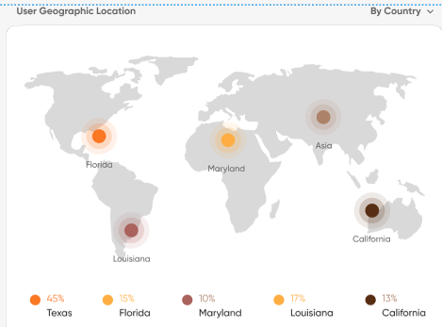
How to approach it:
- User table links to Address via address_id (use a join)
- Address table links to State via state_id (use a join)
- State table links to Country via country_id (use a join)
- Group by state (or country, depending on "By Country" filter selection)
- Count users per state/country using COUNT(user_id)
- Calculate total users across all locations
- Calculate percentage: (users in this location / total users) * 100
- Sort by user count DESC to show highest concentration first
- Optional: LIMIT to top 5 or top 10 locations for cleaner visualization

Example #9 - Query
Top Users
Section
Dashboard
Image
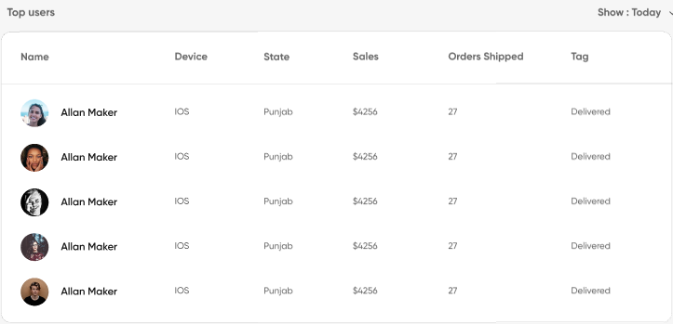
How to approach it:
- User table has user name and device_operating_system field
- User table links to Address via address_id (use a join)
- Address table links to State via state_id (use a join)
- User table links to Orders via user_id (one-to-many)
- Orders table has order_amount to calculate total sales per user
- Orders table has order_status_id to get latest order status (for Tag column)
- Count orders per user using COUNT(order_id)
- Sum sales per user using SUM(order_amount)
- Group by user_id to aggregate order count and sales
- Filter by date range (e.g., WHERE order_date = TODAY for "Show: Today")
- Get most recent order status for each user as "Tag"
- Sort by total sales DESC to show top users
- LIMIT to top 10 or top 20 users

